# Contents

Contents 1

I. Definition 2

Project Overview 2

Problem Statement 2

Metrics 2

II. Analysis 4

Data Exploration 4

Exploratory Visualization 5

Algorithms and Techniques 6

Benchmark 7

III. Methodology 9

Data Pre-processing 9

Implementation and refinement 9

IV. Results 10

Model Evaluation and Validation (Daily forecast) 10

Model based on the outdoor temperature at Clermont-Ferrand 10

Model based on some extra weather features 10

Model based on extra time features 11

Impact of the training set size 11

Impact of the weather data 12

Half hourly forecast 13

Justification 13

V. Conclusion 14

Free-Form Visualization 14

Reflection 14

Improvement 14

Appendix 1: Results 15

Model based on the outdoor temperature at Clermont-Ferrand 15

Polynomial regressor 15

Random forest regressor 15

Decision tree regressor 15

K-nearest neighbours 16

Neural Network MLP 17

# I. Definition

## Project Overview

The project for this capstone is to predict the electricity consumption in France, to do that RTE the organism that is managing the French electricity network provides an API to access different data related to the network. For the study, the data related to the consumption will be used, these data are provided since January 2008 with a timestep of 30 minutes. For this project, the idea is to create a tool that can predict the daily and the half hourly consumption at a national scale, this tool can be very useful for the energy provider like EDF that has to manage the power sources in France.

To make this analysis, it’s important to know that the electricity is the main energy vector used in France. The electricity consumption will be impacted by the weather condition, there will be a seasonal effect link to the use of the heating systems in the French households. Another aspect to think in the electricity consumption is that the needs will be different in function of the day of the week and the hour of the day.

To complete this project, the following datasets will be used:

* The consumption data of RTE[1]
* The weather data form 63 airport stations from Weather Underground[2]
* The GEOFLA dataset from IGN that provides information on the different cities in France[3]

The last dataset will be used to have a better idea on the repartition of the population in France.

## Problem Statement

The goal of this project is to create an algorithm that will forecast the electricity consumption in France at a daily scale and half hourly scale. To complete this project, I will divide the process to find the right algorithm in different tasks:

* **Daily consumption forecast**
  + Test different algorithms only based on electricity consumption and weather data from the centre of France (just based on the outdoor temperature and the daily consumption) and compare them to the benchmark model
  + Test the impact of the training set size on the model
  + Test the models with different inputs (more weather parameters and time information)
  + Test a second weather dataset based on a combination of all the weather data and the IGN data
* **Half hourly consumption forecast**
  + Try a similar approach than previously

With this find the right model, the different test model will be compared to a benchmark model and different metrics are going to be used to make the comparison.

## Metrics

This project can be classified in the regressor problem category so to assess the quality of the model, the following metrics will be used:

* The r2 score
* The mean absolute error

But it’s important that our model have to be fast to build so another metric to study is the time of execution to build the model.

# II. Analysis

## Data Exploration

About the data, for the RTE dataset the data are clean but there are two categories the definitive data and the intermediary data, for the project the data used will be the one that have the definitive status. This dataset represents 140254 points. In the following table there is a sample of the data provided by RTE.

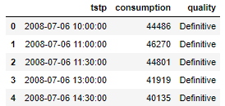

Table 1: Extract of the RTE data

For the weather data, there was some kind of issue in term of data quality, in the weather underground 73 stations seem to be useable for this project but the quality of the data was very various so it has been decided to choose the data that have enough data between the timestamp defined by the RTE data in the definitive status with at least one point per hour. In the case there was some missing points a linear regression has been done to fill the gap. To have a 30 minutes timestamp a resampling has been done. This dataset represents 140254 points. The IGN dataset, was a very clean dataset to use so now specific issue to use it. In the following table there is an extract of the weather from the centre of France that will be used on the first part of the project.

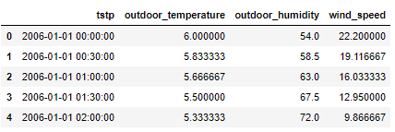

Table 2: Extract of the weather data from the centre of France

To create the second weather dataset that is a combination of all the weather stations collected form weather underground, the following process has been used:

* Associated for each department (state) the weather station closest to the main city in the department
* Gave a weight for each department based on the ratio that the local population represent on the total population
* Made a linear combination of all the weather stations associated with their population weight

In the following table, there is an extract of the second weather dataset that represented the weighted weather dataset.

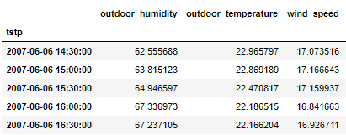

Table 3: Extract the of the weighted weather data

## Exploratory Visualization

For the study, there is seasonal effect on the energy consumption in France, in the following figure there is an illustration of this seasonal effect.

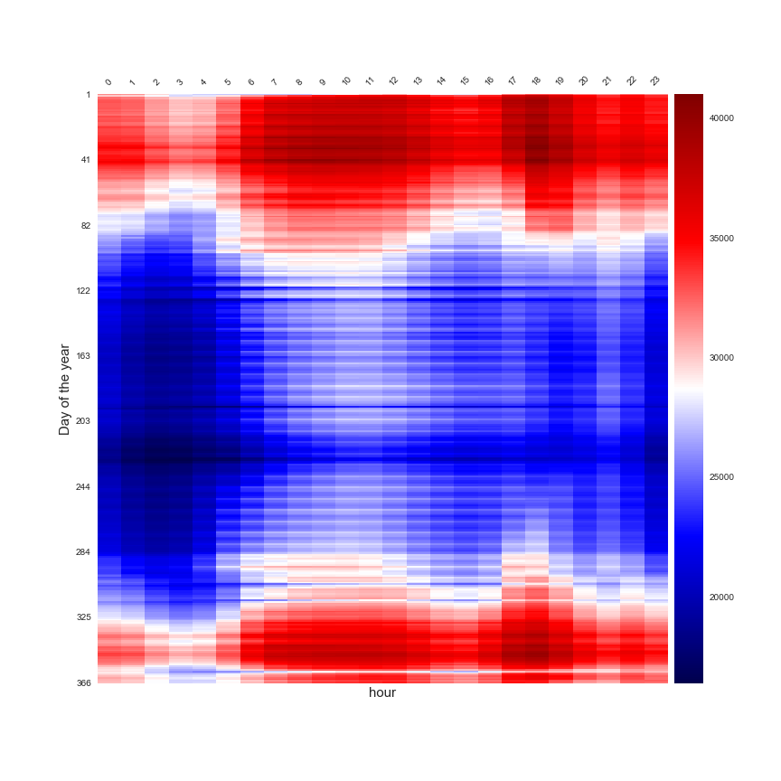

Figure 1: Seasonal effect of the electricity consumption in France in function of the day of the year and the hour of the day

This figure is a good illustration of the impact of the moment of the year in the electricity consumption, it is less important during the summer (blue area in the centre of the heatmap) than during the winter. This heatmap is also an illustration of the variation of the electricity consumption in function of the moment of the day, the consumption seems less important between 0:00 and 07:00 than 07:00 and 12:00, and there is a “peak” between 17:00 and 20:00, this is the illustration of the rhythm of life of French people with the moment where they are active in their household during the “peak of the demand” in the heatmap. Another point to notice is the presence of some lack of consumption during some day , like during the Christmas period it can be noticed that the consumption seems less important than the day of the same month it can be explained by the fact that the industry and the people are in holidays so the consumption will be less important for this moment.

The final point on the seasonal effect analysis illustrate that in function of the day the consumption can be different. In the following figure there is an illustration of the consumption in France in function f the day of the week and the month of the year.

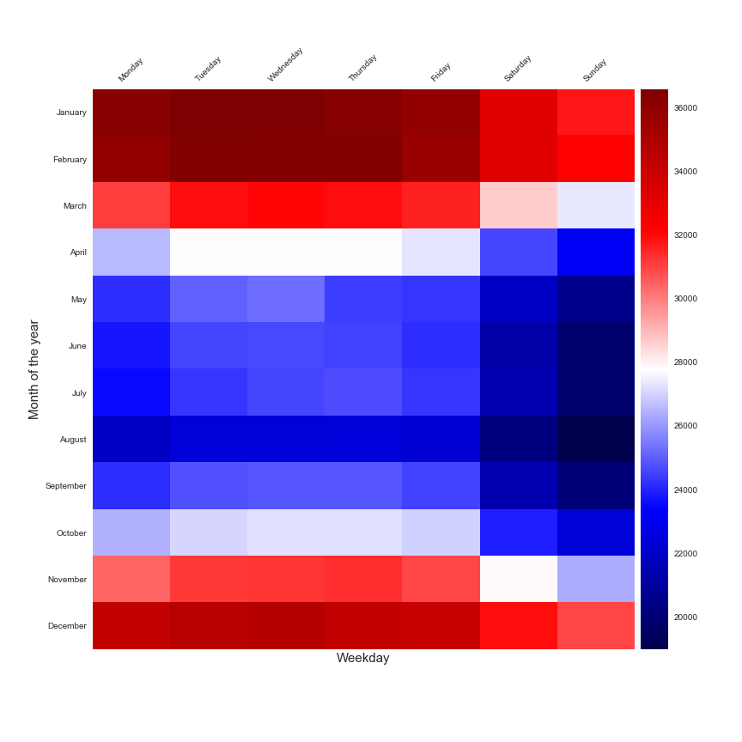

Figure 2: Heatmap of the average consumption in function of the day of the week and the month of the year

This heatmap illustrate the difference between the day of the week for the same kind of month, there is consumption difference between the working days (Monday to Friday) and the day off (Saturday Sunday).

## Algorithms and Techniques

For the analytics, the work will be focus on the regressor approach to estimate the consumption. The library Scikit learn[4] is going to be used to make the project.

It will be test the following models:

* Polynomial regressor[5]
* Random forest regressor[6]
* Decision tree regressor[7]
* K-nearest neighbours[8]
* Neural network MLP regressor[9]

For each model some parameter is going to be modified to find the better combination that fit for our problem. There is a list of the parameters that are going to be tune during the study:

* Polynomial regressor: degree
* Random forest: max depth
* Decision tree: max depth
* K-Nearest neighbours: number of neighbours and weights technics
* Neural network: number of hidden layers, the activation function and the kind of solver

To create the model and find the right model, it’s have been decided to split the dataset between a training set (80% of the dataset) and a testing set (20% of the dataset), the dataset has been randomised before the split.

In the case of the daily consumption that represents:

* Training set: 2337 samples
* Testing set: 585 samples

For the half hourly consumption:

* Training set: 112176 samples
* Testing set: 28080 samples

During the model development, the K-fold segmentation[10] is going to be used to create the best model based on the training set, the number of fold is going to be 10. The evaluation of the best model during the K-fold training is based on the best r2 score.

## Benchmark

There will be two models to surpass, one for the daily forecast and one for the half hourly forecast.

For the daily consumption a piecewise linear approach is going to be used like explained in this paper[11].In this approach just the daily electricity consumption and the outdoor temperature (the Clermont Ferrand data are going to be used). In the following figure there is an illustration of this model.

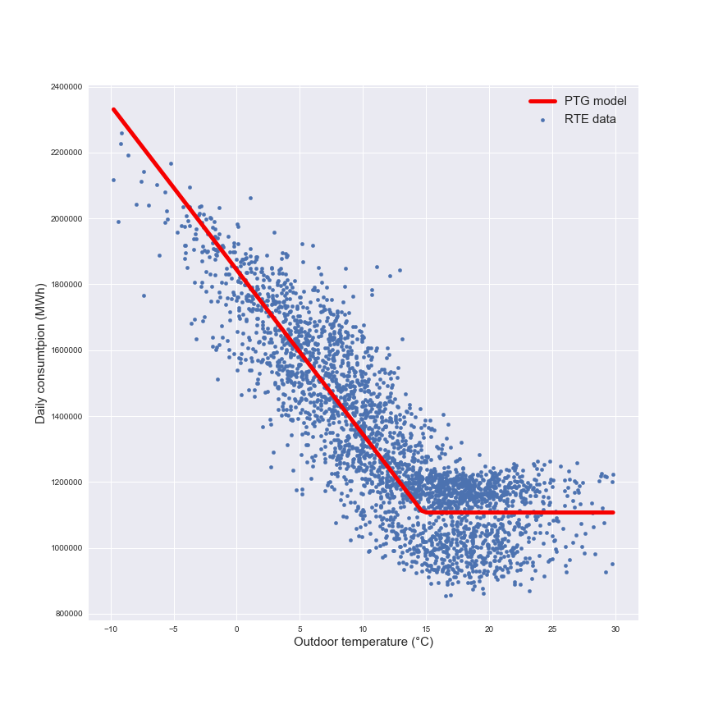

Figure 3: Illustration of the PTG model based on the RTE data and the outdoor temperature in Clermont-Ferrand

This approach illustrates the seasonal effect on the electricity consumption with the two parts on the model. In the following table there is an illustration of the efficiency of this model.

|  |  |
| --- | --- |
| **r2 score** | **Time of execution (seconds)** |
| 0.757 | 0.021 |

Table 4:Metrics for the PTG model

The score for this model are not too bad with a r2 score of 0.75 and the execution time is quite short.

For the half hourly forecast, this a time series problem so there is a model based on the moving average call ARIMA model[12] it’s going to be our benchmark model of the half hourly consumption. It’s only based on the electricity consumption.in the following stable, there is a representation of his efficiency.

|  |  |
| --- | --- |
| **r2 score** | **Time of execution (seconds)** |
| -0.662 | 0.014 |

Table 5: Metrics for the ARIMA model

This model is not a good, so it’s gonna be easy to create better model and the works did on the daily consumption will give the keys to make this better model.

# III. Methodology

## Data Pre-processing

For this part, the pre-processing is quite straight forward. To create the model a join has to done between the weather data and the RTE for each approach the library pandas[13] is perfect to do this part of the project.

In the case of the daily consumption, a sum function has to be used on the electricity data and for the weather data an average function has to be used. It has been notice that there is an impact of the day of the week, the month of the year and the moment of the day so these features are going to be add in the dataset with the use of the built-in functions of pandas to convert a timestamp in another time index.

For the first part of the model only the outdoor temperature is going to be used but for the next when some extra features are going to be added like the weather parameters and the time information the input date have to be normalised to limit the impact of some different order parameters.

## Implementation and refinement

In each case for the two-forecast systems, it will have to test tune each parameter on the different models selected previously. For each model there will be the efficiency metrics associated.

For the polynomial regressor system, the degree used will be modified, the range of study will be between 0 and 15. For the random forest and the decision tree regressors, the maximum depth of the tree will be modified between 2 and 15. In the case of the K-nearest neighbours the number of neighbours will be modified between 1 and 30 and the weight functions will be the uniform functions or the distance functions. On the neural network regressor, the number of hidden layers will be modified between 2 and 256, the activation functions could be the identity, the logistic, the tanh or the relu functions and for the solver is will lbfgs or adam.

There will be four steps on the analysis for each forecast system:

* Test with the outdoor temperature at Clermont-Ferrand
* Add of new features (find the right combinations of features)
* Limit the number of data for the training set
* Test a new weather dataset (the national one)

For each step, the process wants to have a grid search that can permit the evaluation of the accuracy of the model on the different configurations tested.

# IV. Results

## Model Evaluation and Validation (Daily forecast)

### Model based on the outdoor temperature at Clermont-Ferrand

To present the result of the analysis, the representation will be the r2score in function of the execution time but you can find in the appendix the table that contains all the result of the analysis (with the mean absolute error).

In the following table there is the result for each main model used wit hther metrics associated and the parameter of the models.

|  |  |  |  |
| --- | --- | --- | --- |
| **Models** | **Parameters** | **r2 score** | **Time of execution (s)** |
| Polynomial regressor | Degree = 15 | 0.7504 | 0.005 |
| Random forest regressor | Max depth = 4 | 0.7688 | 0.017 |
| Decision tree regressor | Max depth = 4 | 0.7669 | 0.004 |
| K-nearest neighbour | Number of neighbours =19  Weights = uniform | 0.7652 | 0.005 |
| Neural network MLP | Hidden layer size = 256  Activation = relu  Solver = lbfgs | 0.7713 | 0.651 |

Table 6: Best models for the daily forecast (based on outdoor temperature at Clermont-Ferrand)

If the comparison is based on the r2 score, the polynomial regressor with a degree of 15 is the worst model but it’s very close of the PTG model our benchmark model. In another metrics like the time of execution the neural network is very slow like 30 times the PTG model, the other models are quite fast. The more appropriate models seems to be:

* Random forest regressor
* Decision tree regressor
* K-nearest neighbour

### Model based on some extra weather features

In this part, the focus will be made on the model that works fine previously for each main category but the outdoor humidity and the wind speed will be added in the input features. In the following table, there is the results for the models.

|  |  |  |  |
| --- | --- | --- | --- |
| **Models** | **Parameters** | **r2 score** | **Time of execution (s)** |
| Polynomial regressor | Degree = 15 | 0.7667 | 0.099 |
| Random forest regressor | Max depth = 4 | 0.7788 | 0.026 |
| Decision tree regressor | Max depth = 4 | 0.7737 | 0.003 |
| K-nearest neighbour | Number of neighbours =27  Weights = uniform | 0.7781 | 0.003 |
| Neural network MLP | Hidden layer size = 256  Activation = relu  Solver = lbfgs | 0.7847 | 1.699 |

Table 7: Models for the works on the extra weather features

In terms of r2 score, all the model seems better than the PTG but the gain of efficiency it’s not very important for each model. The only model that has change his parameter is the k-nearest neighbour that has a higher number of neighbours.Except for the neural network, the time of execution is quite similar than for the PTG even with more features. For the next steps, it will be chosen to not add the two new features on the model.

### Model based on extra time features

Like for the previous part, two new features will be added to the input features the type of day and the month of the year. In the following table, there is the results for the models.

|  |  |  |  |
| --- | --- | --- | --- |
| **Models** | **Parameters** | **r2 score** | **Time of execution (s)** |
| Polynomial regressor | Degree = 15 | 0.902 | 0.108 |
| Random forest regressor | Max depth = 4 | 0.877 | 0.017 |
| Decision tree regressor | Max depth = 4 | 0.856 | 0.004 |
| K-nearest neighbour | Number of neighbours =19  Weights = uniform | 0.917 | 0.002 |
| Neural network MLP | Hidden layer size = 256  Activation = relu  Solver = lbfgs | 0.921 | 1.826 |

Table 8: Models for the works on the extra time features

The models are improving with these new features, it’s kind of normal after the different observations that have been done on the seasonal and weekday effect. This point is very important for the next steps of the analysis. It’s interesting know to works on the impact of the size of the training set to detect the model that can overfit.

### Impact of the training set size

In the following figure, there is a representation of the impact of the number of points in the r2 score of the model on the testing set.

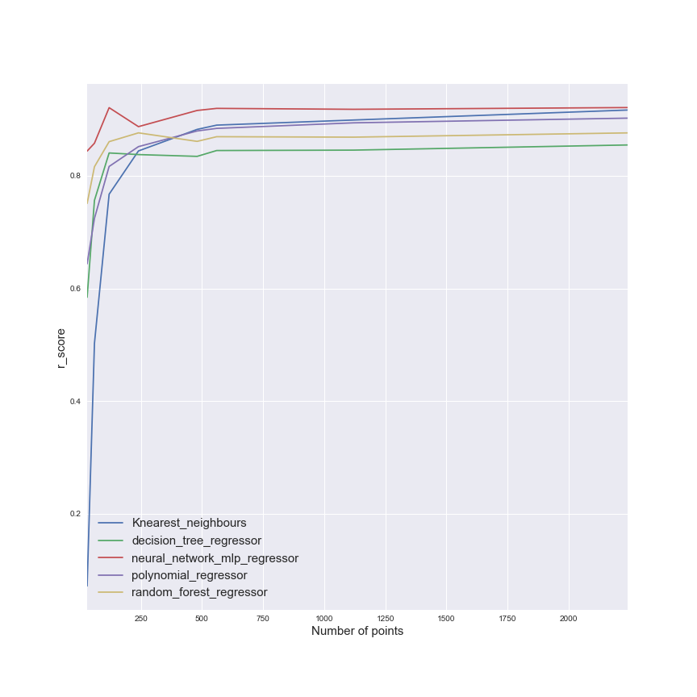

Figure 4: Evolution of the r2 score in function of the number of points in the training set

This figure illustrates that the neural network is quite efficient quickly with a little amount of data, but basically after 2 years of data the model seems to reach his most efficiency parameter.

### Impact of the weather data

|  |  |  |  |  |  |
| --- | --- | --- | --- | --- | --- |
| **Models** | **Parameters** | **r2 score (Clermont-Ferrand data)** | **r2 score (National data)** | **r2 score (National data + more weather data)** | **r2 score (National data + more time data)** |
| PTG | | 0.757 | 0.827 |  | |
| Polynomial regressor | Degree = 15 | 0.75 | 0.811 | 0.829 | 0.92 |
| Random forest regressor | Max depth = 4 | 0.768 | 0.831 | 0.836 | 0.91 |
| Decision tree regressor | Max depth = 4 | 0.766 | 0.831 | 0.829 | 0.898 |
| K-nearest neighbour | Number of neighbours =19  Weights = uniform | 0.765 | 0.823 | 0.831 | 0.931 |
| Neural network MLP | Hidden layer size = 256  Activation = relu  Solver = lbfgs | 0.771 | 0.829 | 0.84 | 0.904 |

Table 9: Impact of the weather data on the r2 score

The models seem more efficient with this new input date, but when some new inputs weather features are added to the training set the gain are very limited. The addition of the time feature is very interesting.

The conclusion on this part of the project is that the national weather data seems more efficient but the choice to use Clermont-Ferrand was not a bad first approximation.

The model that seems the most interesting in term of efficiency and execution is definitely the k nearest neighbours, this model doesn’t to have a lot of parameters to be tuned to reach a very good score.

## Half hourly forecast

To make this forecast, and after the works on the daily forecast it has been decided to choose as inputs:

* The national weather data (only the outdoor temperature)
* The time feature (month, day if the week and half hour of the day)

To obtain a better model of the ARIMA, the focus will be done on the model that have been used for the daily forecast, the PTG is out of the race because to use the PTG it will be necessary to create a model for half hourly slot in a day and it seems not very efficient to do that.

|  |  |  |  |
| --- | --- | --- | --- |
| **Models** | **Parameters** | **r2 score** | **Time of execution (s)** |
| Polynomial regressor | Degree = 8+ | 0.903 | 2.77 |
| Random forest regressor | Max depth = 14 | 0.944 | 1.58 |
| Decision tree regressor | Max depth = 13 | 0.936 | 0.21 |
| K-nearest neighbour | Number of neighbours =28  Weights = distance | 0.945 | 0.26 |
| Neural network MLP | Hidden layer size = 256  Activation = logistic  Solver = lbfgs | 0.93 | 156.28 |

Table 10: Results for the best models of the half hourly forecast

This part illustrates that the models have a better r2score than the ARIMA model, but their time to create is longer than for the ARIMA model.

## Justification

For the daily forecast, the models seem more performant than the PTG model that is our benchmark model. The same result for the half hourly forecast model.

Fir the daily forecast, the model

# V. Conclusion

## Free-Form Visualization

To complete this project, there is a visualisation of the different tested models and the top left area of the figure is the area where the models seems to be more pertinent than the ptg for the daily forecast. There is 3 models that seems good, the k-nearest neighbours is maybe the less interesting model because it’s a model that is overfitting if the data set is too small in comparison of the others methods.

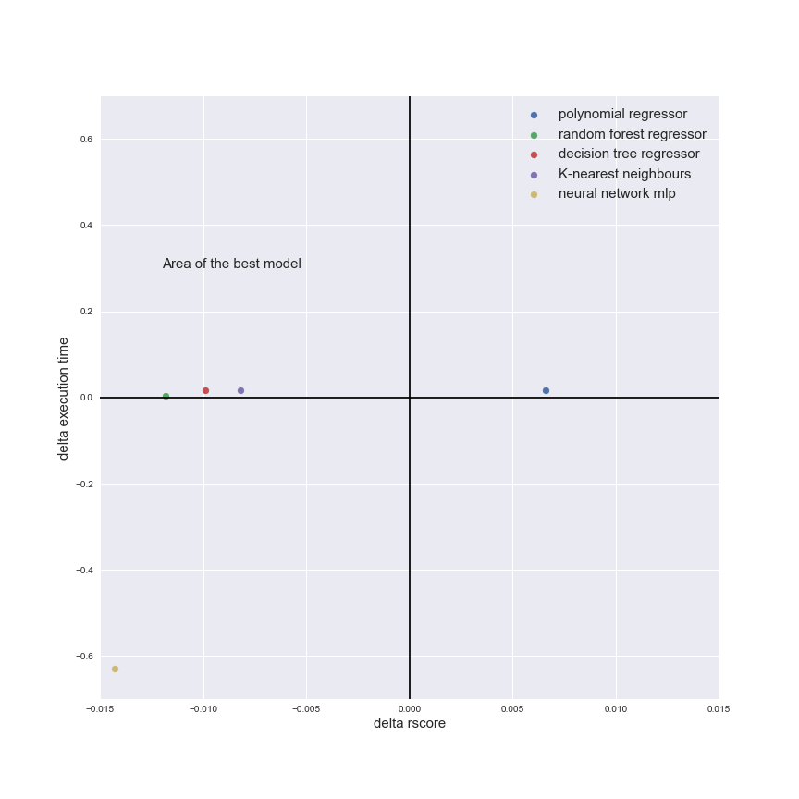

Figure 5: Representation of the model

For the half hourly forecast, every model is better than the ARIMA model tested except the mlp regressor than is a very important execution time.

this section, you will need to provide some form of visualization that emphasizes an important quality about the project. It is much more free-form, but should reasonably support a significant result or characteristic about the problem that you want to discuss. Questions to ask yourself when writing this section:

* *Have you visualized a relevant or important quality about the problem, dataset, input data, or results?*
* *Is the visualization thoroughly analyzed and discussed?*
* *If a plot is provided, are the axes, title, and datum clearly defined?*

## Reflection

In this section, you will summarize the entire end-to-end problem solution and discuss one or two particular aspects of the project you found interesting or difficult. You are expected to reflect on the project as a whole to show that you have a firm understanding of the entire process employed in your work. Questions to ask yourself when writing this section:

* *Have you thoroughly summarized the entire process you used for this project?*
* *Were there any interesting aspects of the project?*
* *Were there any difficult aspects of the project?*
* *Does the final model and solution fit your expectations for the problem, and should it be used in a general setting to solve these types of problems?*

## Improvement

In this section, you will need to provide discussion as to how one aspect of the implementation you designed could be improved. As an example, consider ways your implementation can be made more general, and what would need to be modified. You do not need to make this improvement, but the potential solutions resulting from these changes are considered and compared/contrasted to your current solution. Questions to ask yourself when writing this section:

* *Are there further improvements that could be made on the algorithms or techniques you used in this project?*
* *Were there algorithms or techniques you researched that you did not know how to implement, but would consider using if you knew how?*
* *If you used your final solution as the new benchmark, do you think an even better solution exists?*

# Appendix 1: Results

## Model based on the outdoor temperature at Clermont-Ferrand

### Polynomial regressor

|  |  |  |  |
| --- | --- | --- | --- |
| **models** | **r2_score** | **mean_abs_error** | **execution_time** |
| PR: 0 | -0,00028 | 223060 | 0,005019 |
| PR: 1 | 0,696451 | 117764,5 | 0,004012 |
| PR :2 | 0,746055 | 108075,4 | 0,005015 |
| PR: 3 | 0,750357 | 107224,1 | 0,004015 |
| PR: 4 | 0,750329 | 107243,9 | 0,004513 |
| PR: 5 | 0,750445 | 107217,1 | 0,005514 |
| PR: 6 | 0,750444 | 107217,5 | 0,004513 |
| PR: 7 | 0,750448 | 107216,3 | 0,005014 |
| PR: 8 | 0,750448 | 107216,3 | 0,004512 |
| PR: 9 | 0,750448 | 107216,3 | 0,006016 |
| PR: 10 | 0,750448 | 107216,3 | 0,004503 |
| PR: 11 | 0,750448 | 107216,3 | 0,005515 |
| PR: 12 | 0,750448 | 107216,3 | 0,005013 |
| PR: 13 | 0,750448 | 107216,3 | 0,006517 |
| PR:14 | 0,750448 | 107216,3 | 0,005013 |
| PR:15 | 0,750448 | 107216,3 | 0,005014 |

### Random forest regressor

|  |  |  |  |
| --- | --- | --- | --- |
| **models** | **r2_score** | **mean_abs_error** | **execution_time** |
| RF:2 | 0,747262 | 108781,9 | 0,022092 |
| RF:3 | 0,766777 | 105124,7 | 0,01504 |
| RF:4 | 0,768864 | 104500,3 | 0,017734 |
| RF:5 | 0,765735 | 105304,9 | 0,01905 |
| RF:6 | 0,760363 | 106591,7 | 0,017576 |
| RF:7 | 0,753032 | 108273 | 0,024596 |
| RF:8 | 0,745756 | 109723 | 0,024065 |
| RF:9 | 0,733702 | 112260 | 0,022057 |
| RF:10 | 0,72283 | 113064,5 | 0,026069 |
| RF:11 | 0,71027 | 115494 | 0,026604 |
| RF:12 | 0,706594 | 116218,9 | 0,029079 |
| RF:13 | 0,685869 | 120027,5 | 0,03363 |
| RF:14 | 0,678777 | 120585,7 | 0,031552 |

### Decision tree regressor

|  |  |  |  |
| --- | --- | --- | --- |
| **models** | **r2_score** | **mean_abs_error** | **execution_time** |
| DT:2 | 0,721268 | 112554,6 | 0,005011 |
| DT:3 | 0,759756 | 105876,3 | 0,004036 |
| DT:4 | 0,766962 | 105140,4 | 0,00401 |
| DT:5 | 0,765678 | 105271,1 | 0,004014 |
| DT:6 | 0,752932 | 108286,1 | 0,004016 |
| DT:7 | 0,740599 | 110027,8 | 0,00401 |
| DT:8 | 0,72773 | 113297,2 | 0,005012 |
| DT:9 | 0,711444 | 114928,9 | 0,005053 |
| DT:10 | 0,700739 | 116494,2 | 0,00703 |
| DT:11 | 0,679241 | 120256,2 | 0,006517 |
| DT:12 | 0,672549 | 121764,6 | 0,004986 |
| DT:13 | 0,65595 | 124924,9 | 0,00501 |
| DT:14 | 0,646006 | 126137,8 | 0,005548 |
| DT:15 | 0,642339 | 127282,5 | 0,00501 |

### K-nearest neighbours

|  |  |  |  |
| --- | --- | --- | --- |
| **models** | **r2_score** | **mean_abs_error** | **execution_time** |
| KNN:1/uniform | 0,525106 | 145006,4 | 0,005039 |
| KNN:1/distance | 0,525106 | 145006,4 | 0,005989 |
| KNN:2/uniform | 0,654323 | 125133,6 | 0,004985 |
| KNN:2/distance | 0,619362 | 130605,1 | 0,004012 |
| KNN:3/uniform | 0,683304 | 120228,2 | 0,004011 |
| KNN:3/distance | 0,644205 | 127150,5 | 0,004514 |
| KNN:4/uniform | 0,701642 | 116914,2 | 0,004014 |
| KNN:4/distance | 0,65579 | 124999 | 0,005013 |
| KNN:5/uniform | 0,724702 | 112472,2 | 0,003982 |
| KNN:5/distance | 0,662985 | 123887,1 | 0,004978 |
| KNN:6/uniform | 0,732277 | 111670,4 | 0,004479 |
| KNN:6/distance | 0,668894 | 122674,1 | 0,005014 |
| KNN:7/uniform | 0,737447 | 109763,7 | 0,00448 |
| KNN:7/distance | 0,674098 | 121728,3 | 0,00498 |
| KNN:8/uniform | 0,744979 | 107895 | 0,004014 |
| KNN:8/distance | 0,677536 | 121012,6 | 0,00401 |
| KNN:9/uniform | 0,74743 | 107556,7 | 0,004011 |
| KNN:9/distance | 0,679697 | 120663,3 | 0,005014 |
| KNN:10/uniform | 0,752533 | 107003,6 | 0,004041 |
| KNN:10/distance | 0,681563 | 120300,3 | 0,004506 |
| KNN:11/uniform | 0,755094 | 106450 | 0,004012 |
| KNN:11/distance | 0,683273 | 119845 | 0,004011 |
| KNN:12/uniform | 0,755154 | 106526,5 | 0,004006 |
| KNN:12/distance | 0,684948 | 119543,5 | 0,005002 |
| KNN:13/uniform | 0,758673 | 105684,2 | 0,004548 |
| KNN:13/distance | 0,685669 | 119434,8 | 0,005013 |
| KNN:14/uniform | 0,758487 | 106052,7 | 0,003538 |
| KNN:14/distance | 0,686261 | 119341,7 | 0,004014 |
| KNN:15/uniform | 0,759612 | 105961,1 | 0,003989 |
| KNN:15/distance | 0,68732 | 119130,5 | 0,005013 |
| KNN:16/uniform | 0,758065 | 106135,6 | 0,004013 |
| KNN:16/distance | 0,687402 | 119148,3 | 0,00451 |
| KNN:17/uniform | 0,760401 | 105657,9 | 0,004013 |
| KNN:17/distance | 0,687969 | 119039,2 | 0,005014 |
| KNN:18/uniform | 0,759941 | 105814,9 | 0,005007 |
| KNN:18/distance | 0,688477 | 118950 | 0,005001 |
| KNN:19/uniform | 0,761403 | 105724,2 | 0,004013 |
| KNN:19/distance | 0,689419 | 118802 | 0,003983 |
| KNN:20/uniform | 0,760331 | 106201,1 | 0,004008 |
| KNN:20/distance | 0,690329 | 118668,5 | 0,004011 |
| KNN:21/uniform | 0,760956 | 106428,8 | 0,005013 |
| KNN:21/distance | 0,691069 | 118466,5 | 0,004514 |
| KNN:22/uniform | 0,761696 | 106184,4 | 0,004007 |
| KNN:22/distance | 0,691387 | 118411 | 0,005012 |
| KNN:23/uniform | 0,76276 | 105990 | 0,006037 |
| KNN:23/distance | 0,691842 | 118313 | 0,00401 |
| KNN:24/uniform | 0,76392 | 105589,8 | 0,004993 |
| KNN:24/distance | 0,69218 | 118278,4 | 0,004977 |
| KNN:25/uniform | 0,763955 | 105513,9 | 0,005007 |
| KNN:25/distance | 0,692377 | 118251,9 | 0,004977 |
| KNN:26/uniform | 0,76384 | 105782 | 0,005013 |
| KNN:26/distance | 0,692744 | 118176,5 | 0,004512 |
| KNN:27/uniform | 0,764424 | 105638,3 | 0,004014 |
| KNN:27/distance | 0,692997 | 118163,2 | 0,005014 |
| KNN:28/uniform | 0,765079 | 105427 | 0,005005 |
| KNN:28/distance | 0,693217 | 118116,9 | 0,004009 |
| KNN:29/uniform | 0,765267 | 105376,5 | 0,005008 |
| KNN:29/distance | 0,693451 | 118053,4 | 0,004977 |

### Neural Network MLP

|  |  |  |  |
| --- | --- | --- | --- |
| **models** | **r2_score** | **mean_abs_error** | **execution_time** |
| NN_MLP:2/identity/lbfgs | 0,695703 | 117750,2 | 0,008021 |
| NN_MLP:2/identity/adam | -24,9376 | 1323274 | 0,482284 |
| NN_MLP:2/logistic/lbfgs | -0,00028 | 223060 | 0,01805 |
| NN_MLP:2/logistic/adam | -24,9382 | 1323291 | 0,475263 |
| NN_MLP:2/tanh/lbfgs | -0,00028 | 223060 | 0,014037 |
| NN_MLP:2/tanh/adam | -24,9382 | 1323290 | 0,483285 |
| NN_MLP:2/relu/lbfgs | 0,695703 | 117750,2 | 0,014539 |
| NN_MLP:2/relu/adam | -24,9376 | 1323274 | 0,481281 |
| NN_MLP:4/identity/lbfgs | 0,695703 | 117750,2 | 0,008021 |
| NN_MLP:4/identity/adam | -24,9367 | 1323253 | 0,463232 |
| NN_MLP:4/logistic/lbfgs | -0,00028 | 223060 | 0,02256 |
| NN_MLP:4/logistic/adam | -24,938 | 1323285 | 0,489301 |
| NN_MLP:4/tanh/lbfgs | -0,00028 | 223060 | 0,016043 |
| NN_MLP:4/tanh/adam | -24,9379 | 1323283 | 0,517376 |
| NN_MLP:4/relu/lbfgs | 0,695703 | 117750,2 | 0,011531 |
| NN_MLP:4/relu/adam | -24,9375 | 1323274 | 0,488802 |
| NN_MLP:8/identity/lbfgs | 0,695703 | 117750,2 | 0,008523 |
| NN_MLP:8/identity/adam | -24,9354 | 1323218 | 0,459723 |
| NN_MLP:8/logistic/lbfgs | -0,00028 | 223060 | 0,046122 |
| NN_MLP:8/logistic/adam | -24,9376 | 1323276 | 0,542444 |
| NN_MLP:8/tanh/lbfgs | 0,7642 | 104252,2 | 0,062667 |
| NN_MLP:8/tanh/adam | -24,9376 | 1323274 | 0,612128 |
| NN_MLP:8/relu/lbfgs | 0,695703 | 117750,2 | 0,013035 |
| NN_MLP:8/relu/adam | -24,9366 | 1323249 | 0,513867 |
| NN_MLP:16/identity/lbfgs | 0,695703 | 117750,2 | 0,009526 |
| NN_MLP:16/identity/adam | -24,932 | 1323132 | 0,491808 |
| NN_MLP:16/logistic/lbfgs | -0,00028 | 223060 | 0,061149 |
| NN_MLP:16/logistic/adam | -24,937 | 1323259 | 0,599094 |
| NN_MLP:16/tanh/lbfgs | -0,00028 | 223060 | 0,033591 |
| NN_MLP:16/tanh/adam | -24,9368 | 1323253 | 0,650244 |
| NN_MLP:16/relu/lbfgs | 0,695703 | 117750,2 | 0,015542 |
| NN_MLP:16/relu/adam | -24,9348 | 1323204 | 0,571519 |
| NN_MLP:32/identity/lbfgs | 0,695703 | 117750,2 | 0,012533 |
| NN_MLP:32/identity/adam | -24,925 | 1322950 | 0,507887 |
| NN_MLP:32/logistic/lbfgs | -0,00028 | 223060 | 0,024564 |
| NN_MLP:32/logistic/adam | -24,9356 | 1323222 | 0,775563 |
| NN_MLP:32/tanh/lbfgs | -0,00028 | 223060 | 0,06768 |
| NN_MLP:32/tanh/adam | -24,935 | 1323205 | 0,838732 |
| NN_MLP:32/relu/lbfgs | 0,770608 | 103793,1 | 0,044117 |
| NN_MLP:32/relu/adam | -24,9349 | 1323206 | 0,622154 |
| NN_MLP:64/identity/lbfgs | 0,695703 | 117750,2 | 0,028075 |
| NN_MLP:64/identity/adam | -24,9119 | 1322611 | 0,604608 |
| NN_MLP:64/logistic/lbfgs | -0,00028 | 223060 | 0,100266 |
| NN_MLP:64/logistic/adam | -24,9328 | 1323147 | 0,904405 |
| NN_MLP:64/tanh/lbfgs | -0,00028 | 223059,9 | 0,109794 |
| NN_MLP:64/tanh/adam | -24,9317 | 1323119 | 1,118977 |
| NN_MLP:64/relu/lbfgs | 0,770703 | 103913,6 | 0,20705 |
| NN_MLP:64/relu/adam | -24,9258 | 1322969 | 0,77456 |
| NN_MLP:128/identity/lbfgs | 0,695703 | 117750,2 | 0,051637 |
| NN_MLP:128/identity/adam | -24,8849 | 1321914 | 0,659755 |
| NN_MLP:128/logistic/lbfgs | -0,00028 | 223060,2 | 0,333387 |
| NN_MLP:128/logistic/adam | -24,9272 | 1322999 | 1,300959 |
| NN_MLP:128/tanh/lbfgs | -0,00028 | 223060 | 0,246155 |
| NN_MLP:128/tanh/adam | -24,925 | 1322940 | 1,735116 |
| NN_MLP:128/relu/lbfgs | 0,770745 | 103880,3 | 0,414603 |
| NN_MLP:128/relu/adam | -24,9157 | 1322710 | 1,009684 |
| NN_MLP:256/identity/lbfgs | 0,695703 | 117750,2 | 0,088234 |
| NN_MLP:256/identity/adam | -24,831 | 1320521 | 0,75952 |
| NN_MLP:256/logistic/lbfgs | 0,722619 | 107850 | 2,559307 |
| NN_MLP:256/logistic/adam | -24,916 | 1322704 | 1,838891 |
| NN_MLP:256/tanh/lbfgs | -0,00028 | 223060 | 0,503338 |
| NN_MLP:256/tanh/adam | -24,9116 | 1322585 | 3,03106 |
| NN_MLP:256/relu/lbfgs | 0,771357 | 103648,8 | 0,654742 |
| NN_MLP:256/relu/adam | -24,8896 | 1322035 | 1,453366 |

1. https://rte-opendata.opendatasoft.com/explore/dataset/cdc_conso/?disjunctive.qualite
2. https://www.wunderground.com/
3. http://professionnels.ign.fr/geofla
4. http://scikit-learn.org/stable/
5. http://scikit-learn.org/stable/auto_examples/linear_model/plot_polynomial_interpolation.html
6. http://scikit-learn.org/stable/modules/generated/sklearn.ensemble.RandomForestRegressor.html
7. http://scikit-learn.org/stable/modules/generated/sklearn.tree.DecisionTreeRegressor.html
8. http://scikit-learn.org/stable/modules/neighbors.html
9. http://scikit-learn.org/stable/modules/generated/sklearn.neural_network.MLPRegressor.html
10. http://scikit-learn.org/stable/modules/generated/sklearn.model_selection.KFold.html
11. ttp://www.ibpsa.org/proceedings/BS2015/p2854.pdf
12. https://machinelearningmastery.com/arima-for-time-series-forecasting-with-python/
13. http://pandas.pydata.org/